adroVision
V70
User Manual

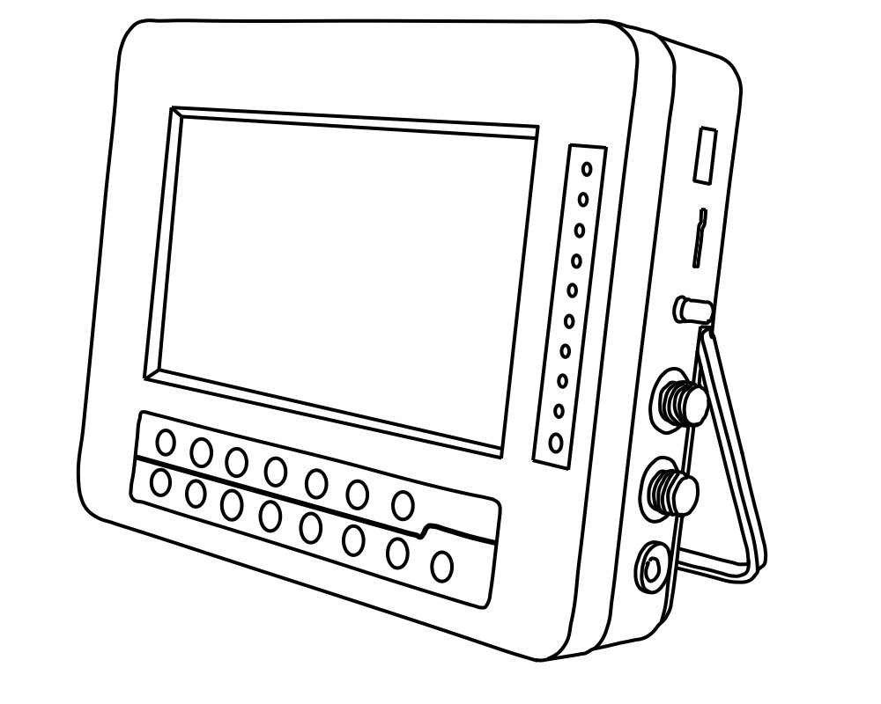

Read the user manual carefully before using this system
User Manual
======== Content ========
- Introduction --------------------------------1
- Main Unit & Accessories -------------------2
- Functions -----------------------------------3
- Operating Instruction ----------------------7
  - Basic Operation -------------------------7
  - Preview Mode --------- -----------------7
  - DVR Mode ------------------------------8
  - Taking Videos/Photos ------------------14
  - Playback --------------------------------14
- Technology Parameter ---------------------15
- FAQ -----------------------------------------16
7. Application ----------------------------------17
      - Introduction
adroVision V70 is a device consisting of a articulation, rigid, semi rigid, fiber-glass or flexible tube with a 7 inch digital quality monitor on one end.
adroVision V70 is used for inspection work where the area to be inspected is inaccessible by other means for example: aircraft engines, aeroderivative industrial gas turbines, steam turbines, diesel engines, and automotive and truck engines to prevent unnecessary maintenance, which can become extremely costly for large turbines.
adroVision V70 can be also used in manufacturing of machined or cast parts to inspect critical interior surfaces for burrs, surface finish or complete through-holes. Other common uses include forensic applications in law enforcement and building inspection, and in gunsmithing for inspecting the interior bore of a firearm.
adroVision V70 can be also used in Medicare as a Visual inspecting for endoscope system.

      - Monitor and Part List
① adroVision V70
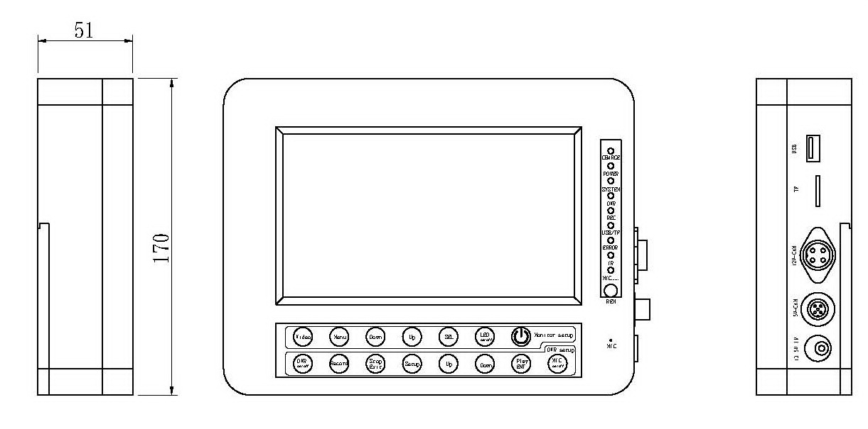
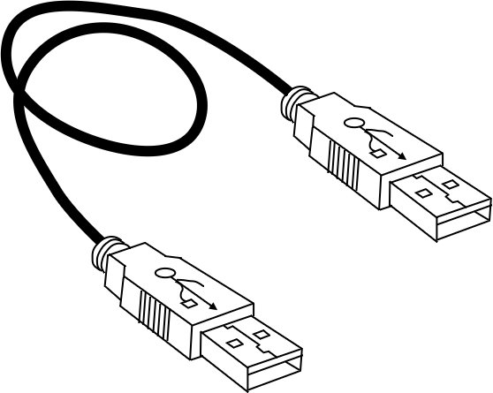
② Remote Control ③ DC 13.5V Power Adapter USB cable TF card
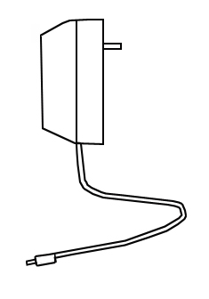
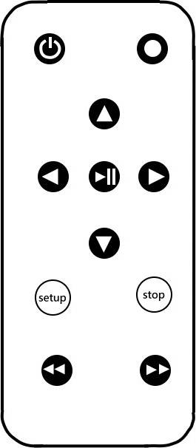
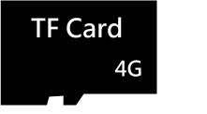

      - Function
Monitor Key Instruction
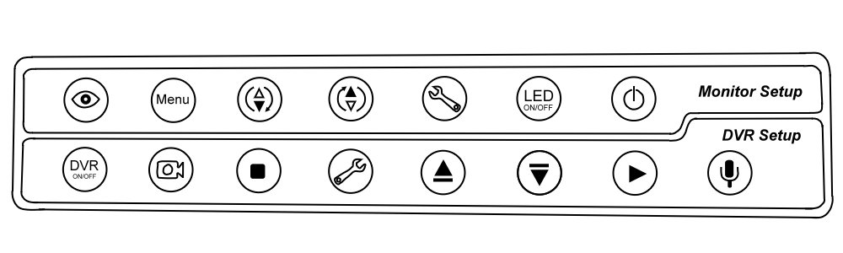
(Photo2-1)
⑴ |  | Video Selector  Video1 is Preview Mode, Video2 is DVR/Recording Mode
⑵ |  | Video Setting Menu
⑶ |  | Move the selection to decrease.  Under Preview Mode, press this button to change image direction upside down.
⑷ |  | Move the selection to increase.  Under Preview Mode, press this button to swap the right and left side of the image.
⑸ |  | Under Video 1 Mode (Preview Mode), press button to change monitor ratio.（16：9/4:3）
⑹ |  | LED On/Off for 12V Inspection Video Scope
⑺ |  | Power On/Off
⑻ |  | Under VIDEO 2 MODE，DVR system on/off
⑼ |  | Video Recorder Key
⑽ |  | 1. Stop recording  2. Stop/Exit and return to the System Menu  3. Press the button to return to the DVR/Video MODE when you are in the System Menu
⑾ |  | DVR Setup  1.Enter/Exit main menu  2. Press the button for 3-5 seconds to delete the file.
⑿ |  | 1. Fast Rewind Key  2. Move the selection to the upper one  3. Under the Date Setup, press this button to increase the date.
⒀ |  | 1. Fast Forward Key  2. Move the selection to the lower one  3. Under the Date Setup, press this button to decrease the date.
⒁ |  | Enter Key  1. Under the DVR MODE, the button is for taking photos.  2. Under the Date Setup, the button is for selecting  3.Videos pause/play
⒂ |  | Microphone On/Off

Side of the monitor
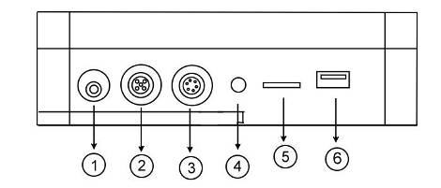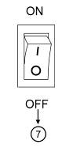
(Photo 2-2)

① | 13.5V IN | Power Jack（13.5V/800mA）  CHARGE Light : RED light→charging，Yellow light→ full charge
② | 5V-CAM | DC 3.5V~5V Camera Port
③ | 12V-CAM | DC 12V Camera Port
④ | LED ADJ | LED ADJ Rotary Switch for V5 camera
⑤ | TF | Micro-SD Card (T-Flash) Memory Card Slot
⑥ | USB | USB Port
⑦ | Power On/OFF | Power Switch（Back of the monitor）

Remote Control Key
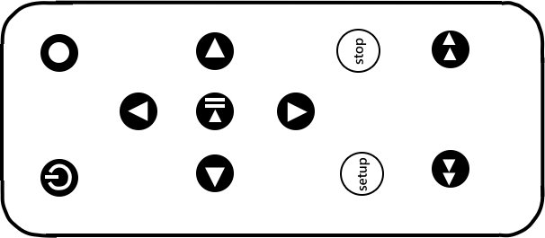
(Photo 2-3)
 |  | Under Video 2 Mode, DVR SYSTEM on/off
 |  | Recording Key
 |  | 1. Under the Menu Mode, move the selection to the upper one.  2. Under the Date Setup, press this button to increase the date.
 |  | 1. Under the Menu Mode, move the selection to the lower one.  2. Under the Date Setup, press this button to decrease the date.
 |  | 1. Enter Key 2. Under the DVR Mode for Taking Photos  3. Under Setting Date, the button is for selecting.  4. During video playing, the button is pause key.
 |  | 1. Press the key to save and exit after finishing settings.  2. Under the video file, you can select “Delete” to delete the chosen file or select “Delete All” to delete all files when you hold on the button 3-5 second.
 |  | 1.Exit Key  2. Press the key to pause the video, press the key again to exit the play.
⑧ |  | Fast Rewind Key
⑨ |  | Fast Forward Key
      - Operating Instruction
Operation Instruction-Basic Operation
●Power On/Off
Power On：Turn on the POWER switch on the back of the Monitor, press POWER button and monitor will light up.
Power Off：Press the POWER button again to turn off the power.

Operation Instruction -Preview
      - Under Video 1 Mode (Preview Mode), press button to enter/exit Parameter Setting. (Photo3-1)

Press  button for selecting the parameter. Press / button to increase and decrease the parameter value.

The definitions are:
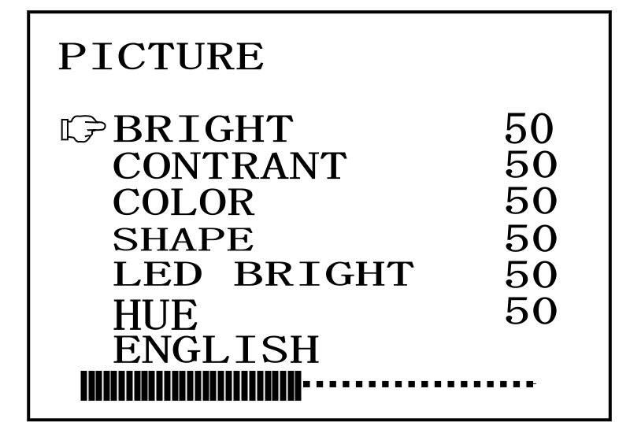
BRIGHT
CONTRAST
COLOR
SHARP
LED BRIGHT
HUE (Photo3-1)

      - Under Video 1 Mode (Preview Mode), press button to change monitor ratio.（16:9/4:3）。
      - Under Video 1 Mode (Preview Mode), press button to change image direction upside down.
      - Under Video 1 Mode (Preview Mode), press button to swap the right and left side of the image
      - Turn On/Off of the12V camera.

Operation Instruction –DVR MODE
Under Video 1 Mode (Preview Mode), press button to enter Video2 and press button Enter/Exit DVR MODE.
            - Main menu:
Press button Enter/Exit Main menu, is Upward Key and Downward Key， and is Enter Key.
There are three parts in the Main menu: Playback（Photo3-2）, System（Photo 3-3）， and Function（Photo 3-4）.
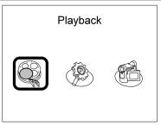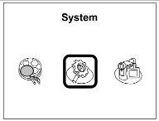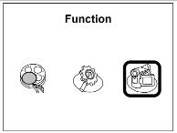
(Photo 3-2) (Photo 3-3) (Photo 3-4)

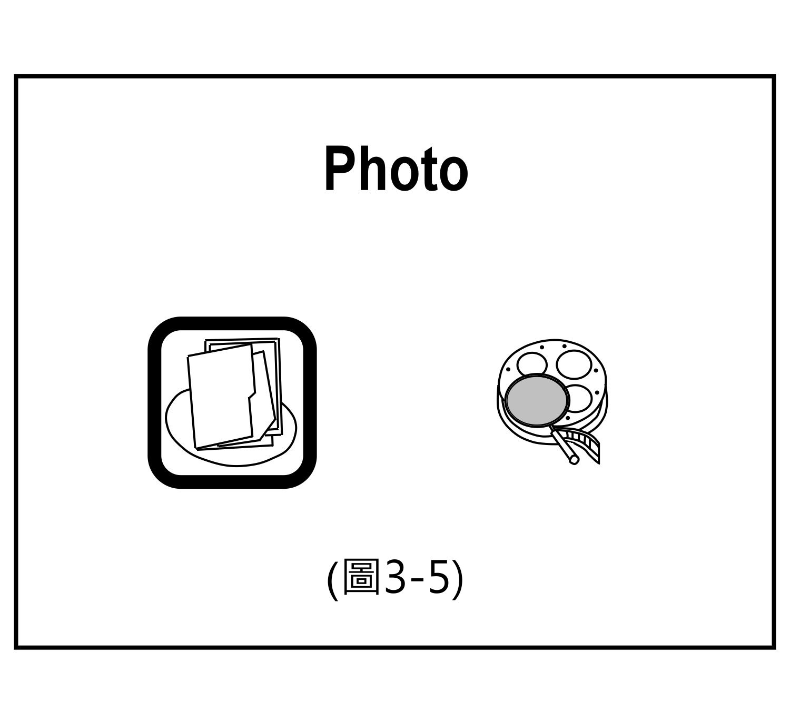
            - Select Playback in the Main menu, press button to enter (Photo3-5). Select Photo or Video with / buttons, press button to browse all video files which is saved in your storage device.

            - Under MENU mode, select "System"， and press button to enter “System Setting” (Photo3-6).
The instructions are:
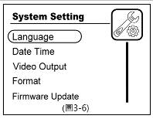
Language
Date Time
Video Output
Format
Firmware Update
Memory Info
Default Setup
Version

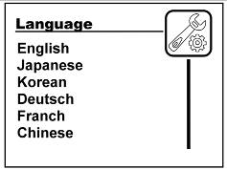
- Language: On System menu, select “Language” and press button to enter (Photo3-7). With / button selecting language item, press button to save and end the setting.
(Photo3-7)

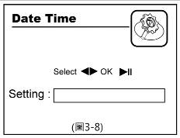
- Date Time: On System menu, select “Date Time” and press button to enter (Photo3-8). Press button to adjust Year/Month/Day/Hour/Minute/Second, and press button to decrease number or press button to increase number. Press button to return to the Main Menu.

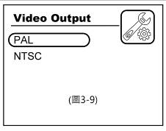
(3) Video Output: On System menu, select “Video Output”, and press button to enter (Photo 3-9). With / button selecting PAL or NTSC, and press button to return to the Main Menu.
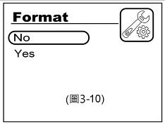
(4) Format: On System menu, select “Format”, and press button to enter (Photo 3-10). With / button to select if it format or not, and press button to return to the Main Menu.
Note：Be careful with this setting, Format will delete all files in the memory card.
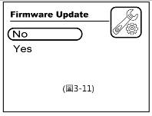
(5)Firmware Update: On System menu, select “Firmware Update”, and press button to enter (Photo 3-11). With / button selecting to firmware update or not, press button to select, and press button to return to the Main Menu.
Please do not cut off the power supply during updating. The machine will shut down automatically after updating.

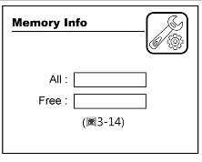
(6) Memory Info: On System menu, select “Memory Info”, and press button to enter (Photo 3-12). It will show all space and used space in Memory Info, and press button to return to the Main Menu.

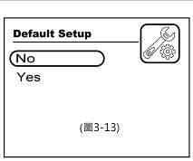
(7)Default Setup: On System menu, select “Default Setup”, and press button to enter (Photo 3-13). With / button selecting to default setup or not and press button to return to the Main Menu.

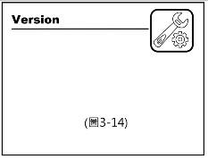
(8)Version: On System menu, select “Version”, and press button to enter (Photo 3-14).

            - Under MENU mode, select “Function ", and press button to enter “Function Setting” (Photo3-15).
The instructions are:
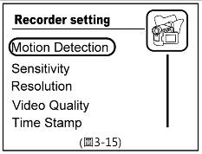
Motion Detection
Sensitivity
Resolution
Video Quality
Time Stamp
Video Time
FPS Set
Overwrite

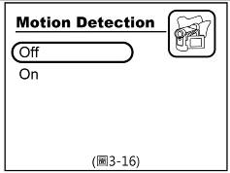
(1) Motion Detection: On Function menu, select “Motion Detection” and press button to enter (Photo 3-16). With / button selecting to close or to open, press button to finish setting and return to the Main Menu.

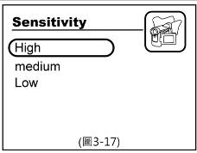
(2)Sensitivity: On Function menu, select “Sensitivity” and press button to enter (Photo 3-17). With / button selecting High/Medium/Low, press button to finish setting and return to the Main Menu.

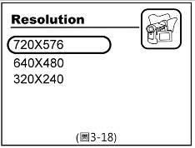
(3)Resolution: On Function menu, select “Resolution” and press button to enter (Photo 3-18). With / button selecting 720X576 / 640X480 / 320X240, press button to finish setting and return to the Main Menu.

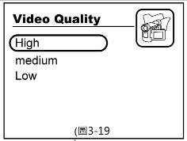
(4)Video Quality: On Function menu, select “Video Quality” and press button to enter (Photo 3-19). With / button selecting High/Medium/Low, press button to finish setting and return to the Main Menu.

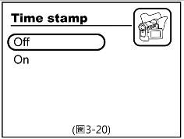
(5)Time Stamp: On Function menu, select “Video Quality” and press button to enter (Photo 3-20). With / button selecting close (not to show time during recording) or open (to show time during recording), press button to finish setting and return to the Main Menu.

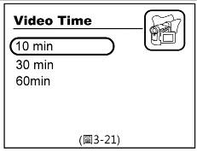
(6)Video Time: On Function menu, select “Video Time” and press button to enter (Photo 3-21). With / button selecting 10 Min(saved automatically at 10 minutes during the recode) / 30 Min (saved automatically at 30 minutes during the recode) / 60 Min ((saved automatically at 60 minutes during the recode)), press button to finish setting and return to the Main Menu.

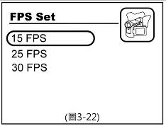
(7) FPS Set: On Function menu, select “FPS Set” and press button to enter (Photo 3-22). With / button selecting 30FPS / 25FPS / 15FPS, press button to finish setting and return to the Main Menu.

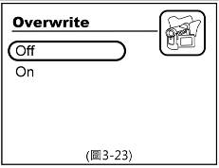
(8)Overwrite: On Function menu, select “Overwrite” and press button to enter (Photo 3-23). With / button selecting close (You cannot take photos and videos when the disk storage is full.) or open (You can overwrite the earliest file when the disk storage is full.), press button to finish setting and return to the Main Menu.

Operating Instruction-Taking Videos/Photos
1. Under “Preview Mode”, press key enter VIDEO 2, and press  key enter DVR MODE. The system date and time will be shown on the top of the right corner of monitor. The Memory Info will be shown on the bottom of the right corner.
⑴Press button or button on the Remote Control to start recording, and press button or button on the Remote Control to stop and save video file. The symbol“” will be shown on the top of the left corner. A red dot will keep glittering means you are taking videos at the same time.
⑵Press button or button on the Remote Control. The monitor will stop for 2-5 seconds, and the symbol of camera will be shown on the monitor.
Note：You have to stand balance when you are taking photo.
(3) Viewing files in surfing mode: Please read Operating Instruction-DVR MODE Playback manual (Page.8)
(4)Play videos on computer: The USB cable connected to the Computer. The monitor will be shown USB Connected. Then you can copy, delete, and play the photos or videos when you under “My Computer”.
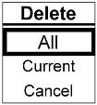
(5) Delete videos: Under video file or folder page, press button or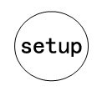 button for 3-5 seconds on the remote control, and you can select “Delete” to delete the file or select “Delete All” to delete all files.
(Photo3-24) (Photo3-24)

Operating Instruction-Play Video
●Playback File：
⑴Photos and Videos are saved in Photo、Video folder.(Photo3-5)
⑵Files are saved in the folder named at the same day.
- Files are named by Year/Month/Day-Year/Minute/Second.

5. Technology Parameter
Type |  | adroVision V70
V70 | The way of recording | Support recording and exploration
V70 | Memory | Support 2G、4G、8G、16G、32G
V70 | Auto-saved Time | 10 minutes、30 minutes、60 minutes
V70 | Image Format | JPEG | Video Recording Format | MP4 /AVI
V70 | Resolution and Store | 720X576：1.2G/hour 640X480：1G/hour 320X240：0.5G/hour
V70 | Repaly | Support replay videos and photos
V70 | Electric Current of Preview | 130mA | Electric Current of Work |  | 650mA
V70 | Language | Chinese、English、German、Russian、Japanese、Korean、French
V70 | Power | 11.1V/3200mAH
Rules | Temperature | -20°~45°
Rules | Humidity | ≤85%
* We won’t notify customers about the specifications if we changed that.

- FAQ

Power On failure | Check Power Switch
Power On failure | Check Battery
Blue Image | Check the Inspection Video Scope
Blue Image | Under VIDEO2, you do not turn on the DVR/Video MODE.
No Recording | Check DVR MODE
No Recording | Check TF card
No Voice | Check MIC on/off

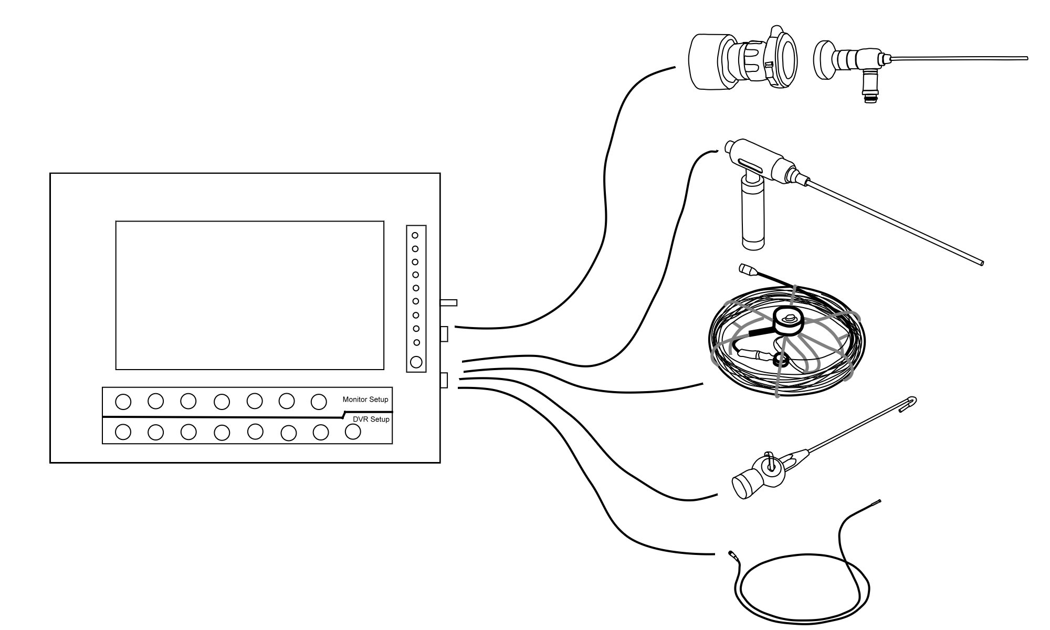
- Application



